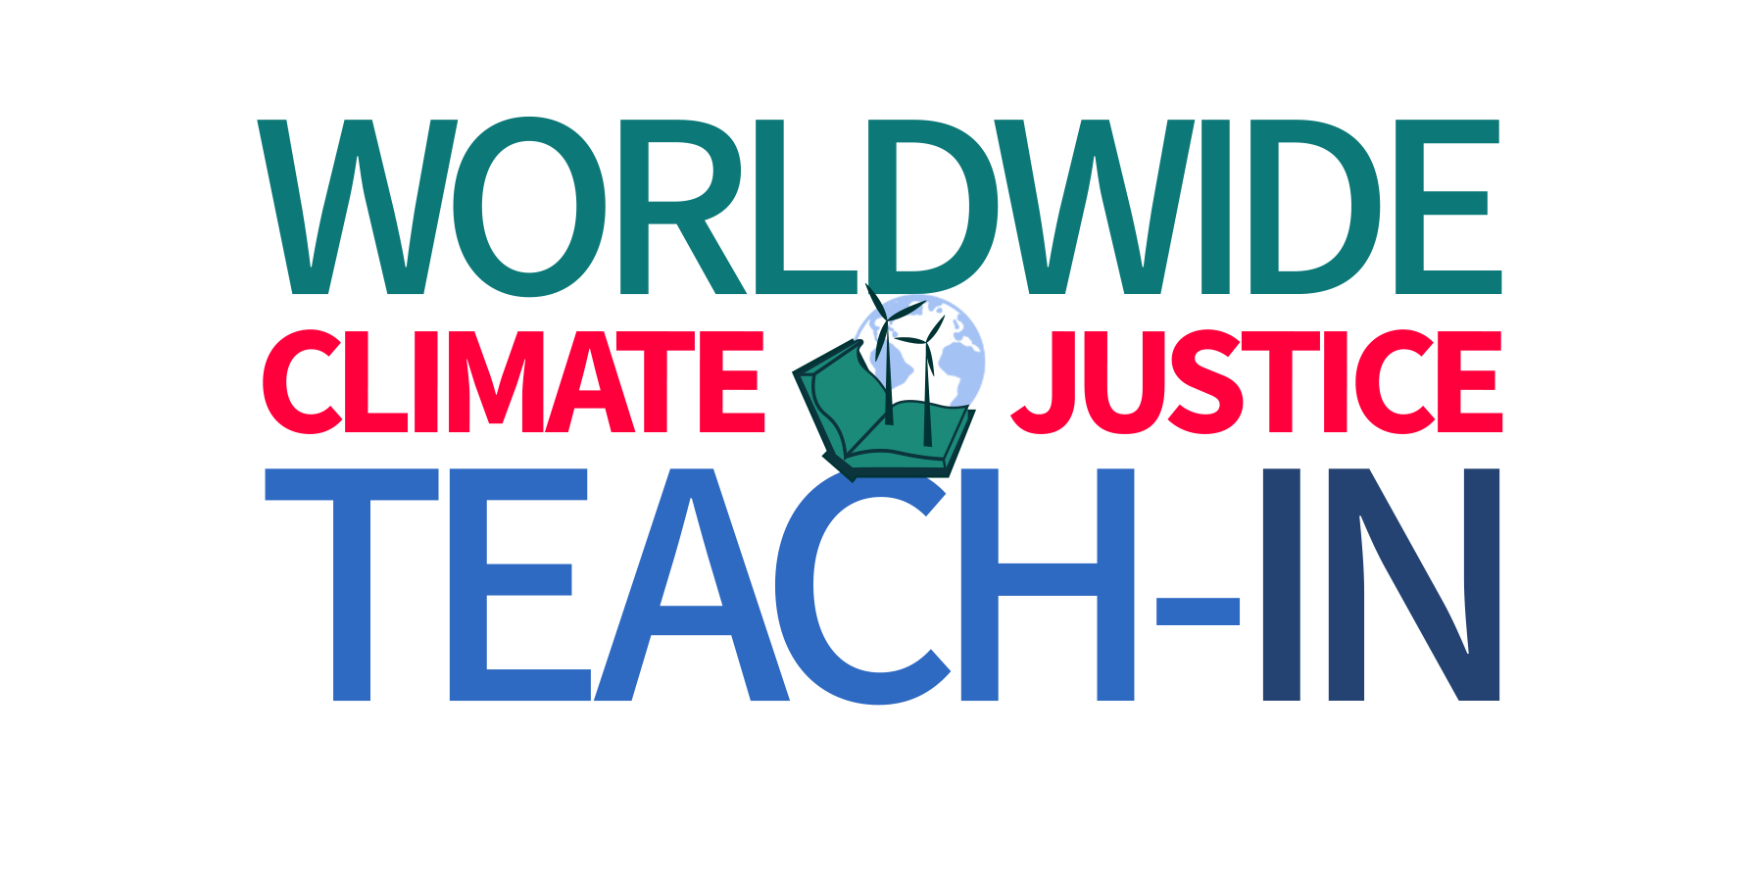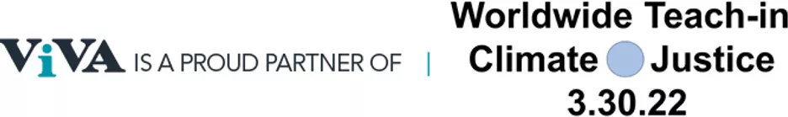Solve Climate 2030 WorldWide Teach-In on Climate and Justice + ViVA

A Few Ideas for Academic Museums & Galleries
We’ve developed a few ideas to get you started. Consider the unique relationships and existing conversations happening on your campus and try to situate a climate justice event or program that will effectively relate to and capitalize on your community’s geographic location, current concerns, and institutional weaknesses and strengths amid the urgent need to transition to net zero. We’re here to help you brainstorm ideas and develop an effective strategy.

- Invite faculty from several disciplines (humanities, arts, social and natural sciences) to present a panel on a climate and justice theme, like racial equity and environmental justice, indigenous practices, biodiversity and biopolitics, or extractivism, deforestation, desertification and economic disparity; scan your faculty for their teaching and research interests and start a conversation;
- Invite a guest speaker (artist, scholar, curator) to keynote a larger series of conversations about climate change and environmental justice scheduled across a single day, week, month or semester that include faculty and museum educator-led discussions with students;
- Consider an entire day or school week of gallery, museum, or collection activities and programs that might include hands-on workshops, nature walks, citizen science contributions or other initiatives that engage participants directly in nature while linking thematically to your museum or gallery exhibitions or specially identified collections objects;
- Invite a co-sponsored and co-presented activity or program with your college or university sustainability staff or representative; consider inviting any sustainability fellows in affiliated academic departments to help build larger attendance;
- Contemplate ways to involve museum interns and other college or university student organizations dedicated to climate and justice concerns; ask them to develop ideas to reach peers and involve their teachers.

SAMPLE ONE-DAY PROGRAM TEMPLATE:
The Solve Climate 2030 WorldWide Teach-In is planned for March 30th, 2022. If you want to develop a full day of programs and activities, consider a schedule like the one provided here. Ask your team to consider how to organize a Teach-In program that includes as many partnerships, potential audiences and active participants as possible. Let us know if you want help thinking about your campus culture, collections and exhibitions, and other important details!

9:00-10:15 AM Breakfast Panel – 4 Faculty Leading a Discussion
Consider picking a theme! Biodiversity and biopolitics, environmental policy and inequality, or another topic that faculty from multiple disciplines can address in short 5-minute introductions followed by a robust wide-ranging conversation. Remember, you can always bring together a wide range of faculty who approach climate change and environmental justice from a spectrum of entry points; they don’t all have to be published experts on climate issues or environmental justice.

10:30 AM-12:00 Noon Hands-On Workshop – Making and Using Natural Dyes
This workshop could begin with a walk on the college’s campus or in the nature preserve to collect the leaves, nuts and branches needed to create natural dyes to use in painting, writing, and printmaking techniques. The process can provide insights into the natural diversity on campus and emphasize the importance of knowing and caring for our environment through conservation, protection of wetlands, and ecosystem restoration.

Lunch Break Local Foods Boxed Lunch or Food Truck
This lunch can provide an opportunity to educate participants about the responsible sourcing, transportation, preparation, distribution and consumption of foods on campus, in our immediate communities, and beyond, including a conversation about sustainable waste management. The college’s current practices and any planned or needed transitions can be highlighted and discussed.

1:30-2:45 PM Afternoon Panel #1 – Sustainability Office + Student
Organizations
Ask your college’s sustainability director and student leaders to lead a discussion about on-campus efforts, measurement and metrics, achieving net zero + how the museum is integrated (or becoming integrated) and brainstorming about future participation and contributions. Invite the museum’s leadership (director, trustees, donors) to talk about their commitments to the college or university effort to reach net zero.

3:00-4:30 PM Afternoon Panel #2 – Collection Highlights
Museum educator/curator-led conversations about how collection objects have documented nature and its changes, environmental injustice and its impact on communities, different cultures’ perspectives on nature, the loss of natural species, effects of extractivism, deforestation, desertification, or other themes that collections might serve to highlight for audiences. Museum curators and educators should take the lead and think creatively about how to leverage objects for this vital conversation.

4:30-5:30 PM Reception in the Museum
As with the organization of the day’s lunch options, use this as a time to educate about responsible food sourcing, transportation, preparation, distribution and consumption, including waste collection and management. Could this be a good time and strategically useful place to install temporary didactic signage about this subject?

5:45-7:00 PM Film Screening
Plan to showcase a documentary about climate change and environmental justice. Consider planning a casual post-screening discussion led by faculty, community members, and/or students.

7:00-8:30 PM Virtual Keynote or Panel
Consider hosting a virtual or live-streamed keynote by an artist or group of artists on a theme, and/or invite a panel of alumni experts to join faculty to speak on a climate justice theme to a combined virtual and in-person audience. Emphasize actions and planning that audience members can incorporate into their individual, family, workplace, community and school contexts. Ask the museum or gallery director to voice a commitment to real actions to support sustainability efforts. Include the museum’s membership and off-campus community members and alumni located around the world through virtual channels. Don’t forget that those with disabilities or who are not able to travel or leave their homes are aided through making this a hybrid format event. Could you also make other activities hybrid to encourage their participation during your day-long focus on climate change and environmental justice?

SPECIAL NOTE:
The Solve Climate 2030 WorldWide Teach-In planned for March 30th 2022 is one opportunity to participate in this important educational conversation. If you cannot manage to organize something for this date, consider other dates in 2022. Also, the Solve Climate 2030 initiative will continue through 2023 (another Teach-In is likely!) and ViVA is available any time to help you brainstorm or develop ideas. Please stay in touch!

